

School of Future Tech

Case Study Report :

Kanban task board

By:

- JIYA JANA - 150096725167
- SHUBH SARASWAT - 150096725132
- AARYAN KENI - 150096725197
- SAMEER MISHRA - 150096725193

Index
1.Introduction to the Case Study.
2.Problem Statement / Case Background (Abstract).
3.Problem Statement / Case Study Design.
4.Methods & Algorithms Technology Applied in the Problem Statement / Case Study.
5.Problem Statement / Case Study Implementation Details and Snapshots.
6.Problem Statement / Case Study Results and Conclusion.
7.References

1.Introduction to the Case Study.
Task management is an essential aspect of productivity in academic, professional, and personal environments. With the increasing use of digital platforms, web-based task management systems have become popular due to their accessibility, flexibility, and ease of use. This case study focuses on the design and implementation of a web-based Task Board application using core web technologies such as HTML, CSS, and JavaScript.
The Task Board visually organizes tasks into different stages of completion, enabling users to track progress efficiently. By adopting a column-based workflow model, the application simplifies task handling and improves user productivity. This project demonstrates how modern front-end technologies can be used to build interactive and visually appealing web applications without relying on external libraries or frameworks.

2.Problem Statement / Case Background (Abstract).
Managing tasks manually or using unstructured digital tools often leads to inefficiency, lack of clarity, and poor progress tracking. Many users require a simple, lightweight, and intuitive system to manage tasks without complex setup or heavy software dependencies.
This case study presents the development of a Task Board system that allows users to create, organize, move, and delete tasks across different workflow stages. The system uses a drag-and-drop mechanism to represent real-world task progression visually. The primary objective is to design a responsive, user-friendly task management interface using only client-side technologies.

3.Problem Statement / Case Study Design.
The Task Board application is designed with the following objectives:
- To provide a simple and interactive task management interface
- To visually represent task progress using multiple columns
- To enable drag-and-drop functionality for intuitive task movement
- To ensure a clean, modern, and responsive user interface
- To avoid external frameworks and rely on pure HTML, CSS, and JavaScript
The design follows a Kanban-style layout with three main columns:
- To Do – Tasks yet to be started
- In Progress – Tasks currently being worked on
- Done – Completed tasks
Each task is represented as a draggable card that can be moved between columns based on its current status.

4.Methods & Algorithms Technology Applied in the Problem Statement / Case Study.

Technologies Used
- HTML5 – Structure and layout of the application
- CSS3 – Styling, animations, layout design, and visual effects
- JavaScript (ES6) – Logic, event handling, and interactivity

Methods and Algorithms Applied
- DOM Manipulation
  - Dynamic creation and deletion of task elements using JavaScript.
- Event Handling
  - Handling user actions such as button clicks, key input, and mouse drag events.
- Drag-and-Drop Mechanism
  - Utilization of dragstart, dragover, and drop events to move tasks between columns.
- Input Validation
  - Ensuring empty tasks are not added to the board.
- CSS Animations
  - Smooth visual transitions and fade-in effects for better user experience.

5.Problem Statement / Case Study Implementation Details and Snapshots.

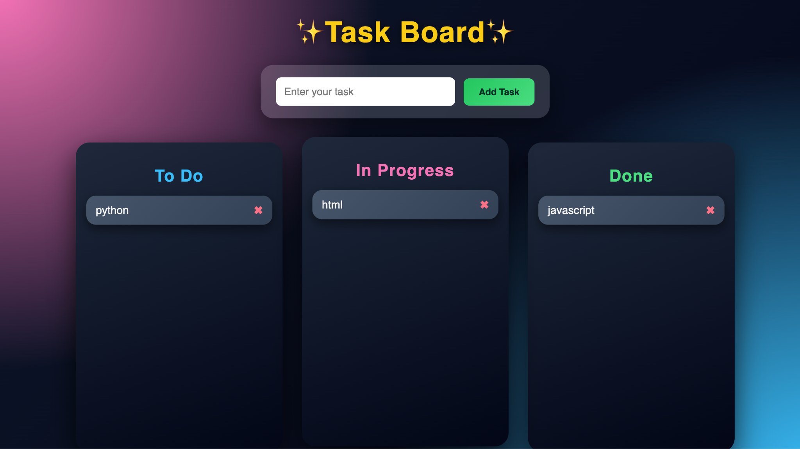

6.Problem Statement / Case Study Results and Conclusion.
The Task Board application successfully fulfills its intended objectives by providing a simple, effective, and visually engaging task management system. The drag-and-drop functionality enhances usability, while the clean interface improves clarity and organization of tasks.
The project demonstrates that powerful and interactive web applications can be built using only core web technologies without external dependencies. This case study also highlights the importance of user-centric design and efficient event handling in modern web development.
In conclusion, the Task Board system serves as an effective solution for basic task management and provides a strong foundation for future enhancements such as data persistence, user authentication, and backend integration.

8.REFERANCE
Core APIs
Drag & Drop API: https://developer.mozilla.org/en-US/docs/Web/API/HTML_Drag_and_Drop_API
DOM Manipulation: https://developer.mozilla.org/en-US/docs/Web/API/Document_Object_Model
Kanban Concept
What is Kanban?: https://www.atlassian.com/agile/kanban
Inspiration
Trello: https://trello.com

